• \* ¢ Ψ ? †

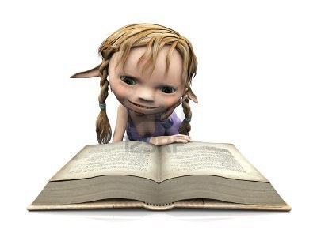

May Day, 2012

~

Hello MAGIC ELF,

Thank you for agreeing to help me with Help Yourself. You and a crack team of other word nerds have very kindly agreed to help me with some proofreading. It seems only right that a book called Help Yourself should be self-published but I cannot do that all by myself. So I would be really appreciate your help.

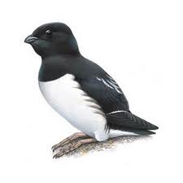For clarity and consistency I’ve included a guideline set of proofreading marks.

Hopefully they are standard, if you are used to something else, feel free to go with that but please try and find me an equivalent crib-sheet.

As well as the usual typos and missing words, I’d be grateful if you could put some wavy lines underneath and the margin mark AWK next to anything you think is clunky, awkward or out of place.

You could also check that character code is correct. As you may have noticed when reading the book. Each section is headed by some symbols for the characters that appear in it.

AWK

• - the man, \* - John, ¢ - Eric, Ψ – Hazel, ? – Shona, † - Rev. Cake, ~ - none of the above

Likewise, I am having a big debate with myself as to whether or not to include the philosophers and all the other ranting interruptions. I’d be interested in what you think about that. I am also looking for good ideas for the what to put on the front cover. I’m going to email you the full pdf to refresh your memory.

There’s no urgency to this so please don’t feel under any pressure. And if it seems like it is going to take longer than you can reasonable justify please let me know and I will try and find some other magical helpers. But if you can help that would great. Your hard work will not go unrewarded. Among the many rewards on offer are:

* Quite a lot drinks
* Acknowledgment in the acknowledgments
* A free copy of the book
* Eternal gratitude
* An especially written short story for any small children you might have

Many thanks,

Caspar

PS It’s already got an ISBN number. Isn’t that exciting?